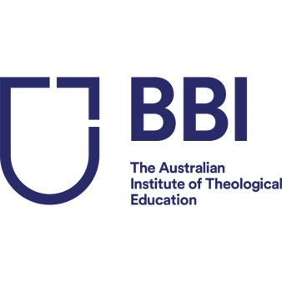

BBI Graduation 2020

Congratulations on having completed your award or course with BBI-The Australian Institute of Theological Education (BBI-TAITE).

Graduation for all eligible students studying with BBI-TAITE will be held on Friday 17th April, 2020 at 11 am. The ceremony will be held at the Caroline Chisholm Centre, 423 Pennant Hills Road, Pennant Hills, NSW, 2120 and will be followed by a light lunch.

Each graduand is allowed up to two guests for the Graduation ceremony and post-graduation refreshments / light lunch.

This form must be filled in and returned even if you are not attending the Graduation ceremony
Please confirm the following by return email on or before 31 January 2020.

- NAME ON TRANSCRIPT (*):
First Name __________________________ Middle Name ______________________
Family Name _____________________________
(*) Please note this must be your full legal name as on your birth certificate or current passport. If you have changed your name and would like the new name on the transcript please indicate above (supporting documentation will be required).

Please circle or highlight the relevant option below:
2. ATTENDING GRADUATION CEREMONY: YES / NO
3. NUMBER OF GUESTS: 0 / 1 / 2
4. DIETARY REQUIREMENTS: (If applicable) Gluten-free/Dairy-free/ Vegetarian/Vegan
5. I AGREE TO MY PHOTOGRAPH BEING YES / NO
TAKEN (it may be used for marketing purposes)

More information on the Graduation ceremony, hiring/purchasing of hoods/gowns (academic dress) will be sent to you later and will also be made available on the BBI-TAITE website here.

Please return this form before 31 January 2020 to studentservices@bbi.catholic.edu.au

